Content Management Administrative User Training Guide

Logging in to your site 3
Wordpress Multisite Admin Features 3
Common Tasks 3
Edit an Existing Page 4
Adding a Link 5
Step 1: Highlight Link Text 5
Step 2: Insert Link URL 5
Inserting a File into the editor 7
Step 1 - Highlight Link Text and Add Media 7
Step 2 - Upload a New File 7
Step 3 – Copy Media File URL 8
Step 4 – Link Text to Media File URL 8
Inserting an Image 8
Step 1 - Select Image Insert Point 8
Step 2 - Choose a File to Upload 9
Step 3 Insert Alt Text 10
Step 4 (Optional) - Select Alignment Type 10
Step 5 (Optional) - Resize Image 11
Step 6 (Optional) - Link Image 11
Step 7 - Insert Image 11
Formatting Images for Display on the Web 11
Images and Accessibility 12
Tips for Writing Alternative Text 12
Definition of a Post 13
Add a New Page to Navigation Menu 13
Add a New Page (Not listed In Navigation) 14
Remove a Page 15
Creating a Draft page 15
Custom Menus 16
Custom Footers 16

Logging in to your site

http://YOURDOMAIN.gov/wp-login.php

- Make sure the URL does not have the word BETA in the URL (e.g., dotbeta.hawaii.gov). There are two sites, one is beta site used for training and testing. The other is your live site. Editing on the beta site will not show changes on the live site.
- If you have lost your password, click the “Lost your password?” link and type in your email.
- Depending on how your department has set up their division sites, your URL will look like this: http://hdoa.hawaii.gov/ai/wp-login.php
Note the division is “ai” and the Department is “hdoa”.

Wordpress Multisite Admin Features

Once logged in, you can access different sites your user account has been assigned to. To find these sites click the “My Sites” link in the upper left of the screen after logging in.

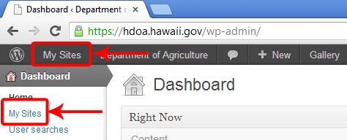
Next click the “Visit” or “Dashboard” link
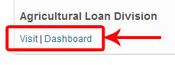

Common Tasks

Edit an Existing Page
- Log in to your website.
- Click the “Admin Bar Site Name”. This is how you can go back and forth between the admin and the live site.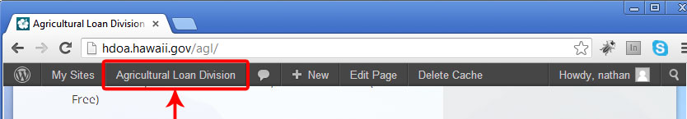
- Navigate to the page you wish to make an edit on and click the admin bar “Edit Page” or scroll to the bottom of a page and click the “Edit this page” link.
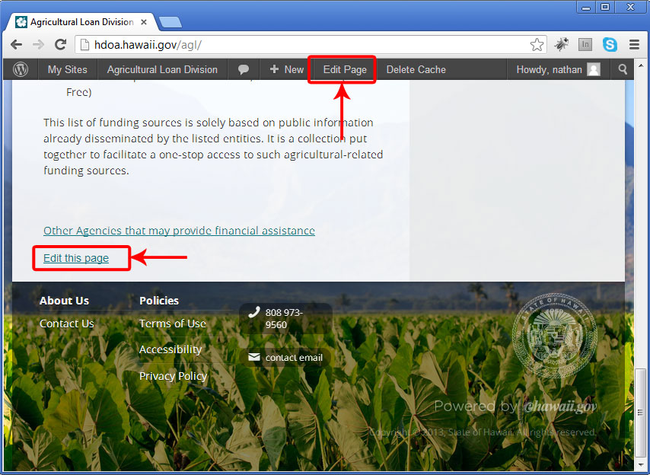
- You can make changes in the WYSIWYG editor and then preview the changes by pressing the “Preview Changes” button:
- Once done editing, click the “Update” button:

Adding a Link

Step 1: Highlight Link Text
- Login to your account
- Click ‘Pages’ (located on left sidebar in the dashboard)
- Click ‘All Pages’
- Hover over the page you want to add a link to
- Click “Edit”
- Highlight the text you want to add a link to
- Click the chain link icon in the editor
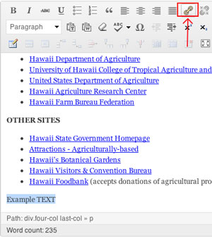

Step 2: Insert Link URL
- If the link is EXTERNAL (not another page hosted on your site)
- Copy and Paste the URL into the box that says “URL”
- Type a title in the “Title” box
- Check the box for “Open link in a new window/tab”
- Click ‘Update’ button:
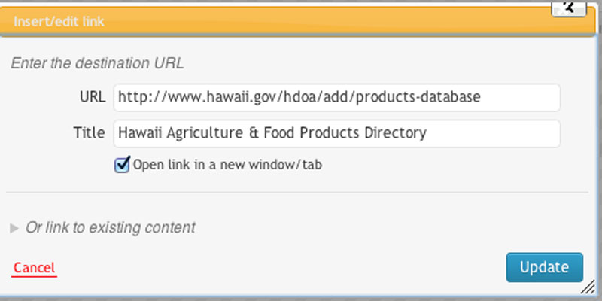

- If the link is INTERNAL
- Click ‘Or link to existing content’
- Click the page you want to link to
- Click ‘Add Link’
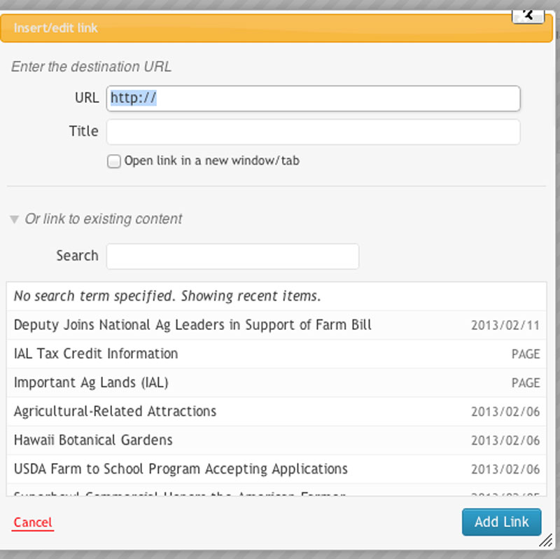

Inserting a File into the editor
You can create a link directly to a file within your File Storage (such as a pdf, Excel, Word document, etc.) which will allow visitors to download this from your site.

Step 1 - Highlight Link Text and Add Media
- Highlight the text you'd like to link to a file.
- Click “Add Media”
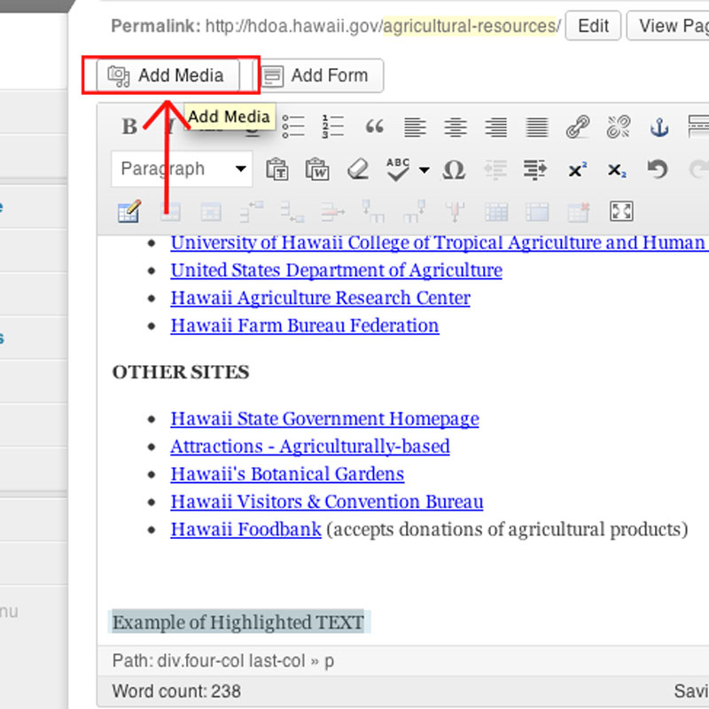

Step 2 - Upload a New File
- In the ‘Upload Files” window, Click “Select Files’
- Select the file from your computer you want to upload
- Click ‘Open’
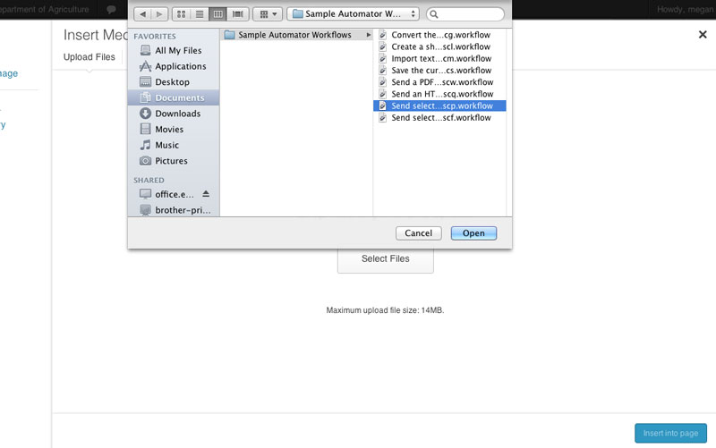

Step 3 – Copy Media File URL
- In the ‘Link to’ drop down menu choose ‘Media File’
- Copy the link that is created
- Close the media window (click the X on the top right)

Step 4 – Link Text to Media File URL

Note: your original text should still be highlighted
- Click the link button in the WYSIWYG editor 
- Paste the link in the ‘URL’ box
- Click the box next to ‘Open link in a new window/tab’
- Click ‘Add Link’

Inserting an Image
- Wordpress’ editor allows you to upload, align, and insert an image within it using the Insert Image button. When inserting images into a page or entry, it's easier if you add your text to the page first and then insert your images in afterwards.
- Before adding any images read “Formatting Images for Display on Web”

Step 1 - Select Image Insert Point
- Point your cursor where you want to insert the image. **Note that this may not always be where the image actually will appear. For example, if you want to insert an image so it is near the top of a paragraph of text and right aligned, then you actually place your cursor at the start of the paragraph just before the first character.
- Click “Add Media”
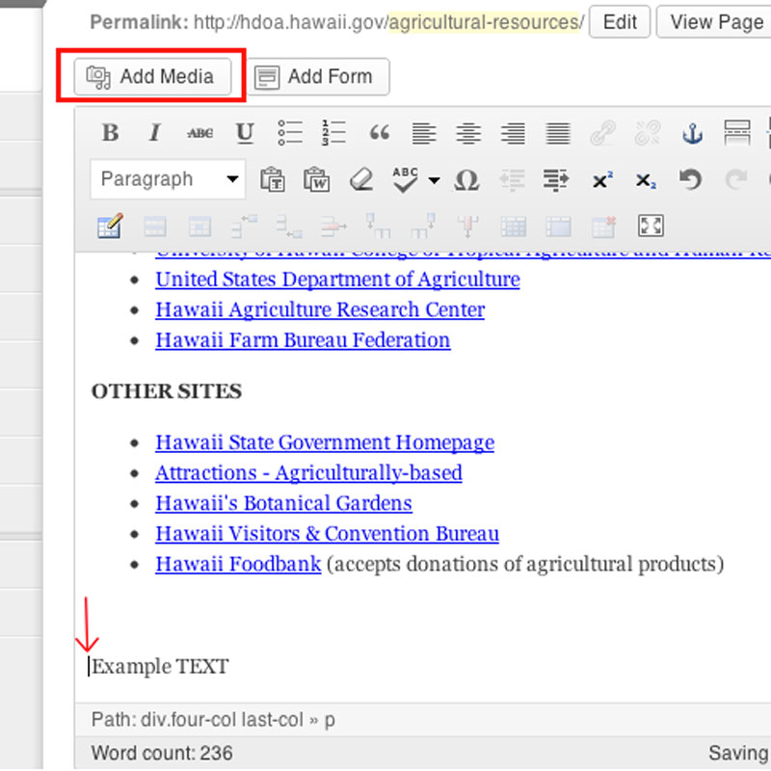

Step 2 - Choose a File to Upload
- In the ‘Upload Files’ window, Click ‘Select Files’ **
- Choose the image you want
- Click ‘Open’

**Note: Image files (GIF, JPG, or PNG file) should be all lowercase with no spaces or punctuation within the file name.

Step 3 Insert Alt Text

Read ‘Tips for Writing Alternative Text’ before proceeding.
- Once uploaded, you'll see the image previewed to the right of the screen in the ‘Attachment Details’ window.
- Scroll down to ‘Alt Text’
- Type your alt text in the box provided

Step 4 (Optional) - Select Alignment Type
- Once uploaded, you'll see the image previewed to the right of the screen in the ‘Attachment Details’ window.
- Scroll down to ‘Alignment’
- Click the arrows next to ‘none’ and choose an alignment
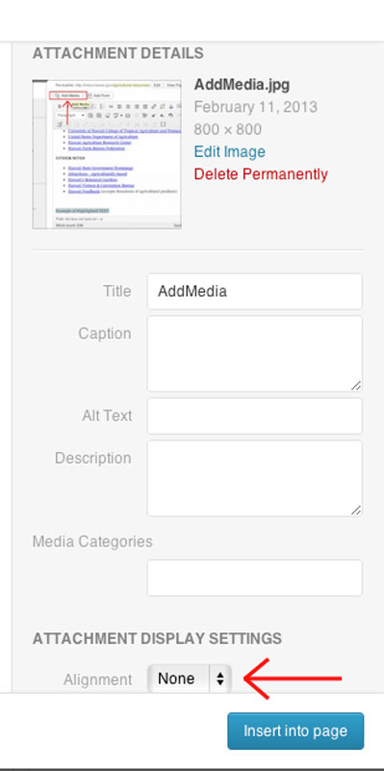

Step 5 (Optional) - Resize Image
- In the ‘Attachment Details’ window
- Click the arrows next to ‘Size’
- Choose either Thumbnail, Medium, or Full Size

Step 6 (Optional) - Link Image
- In the ‘Attachment Details’ window
- Insert the URL you want the image to link to
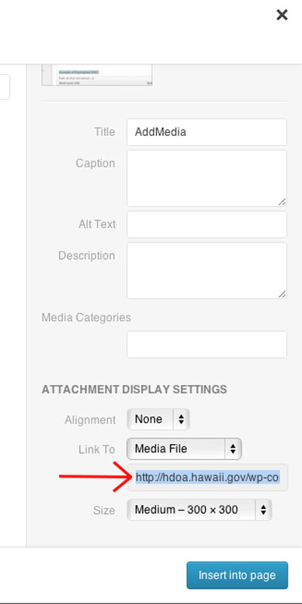

Step 7 - Insert Image
1. Finally, click ‘Insert into Page’ for your image to be inserted.

Formatting Images for Display on the Web
All images you upload should be web-optimized. We recommend following these guidelines:
- Size your images exactly as you want them to appear on your site to eliminate pixelization. You should not have high resolution images.
- Try to keep file sizes under 100K. The longest side of your image should be no larger than 800px.
- Save in JPG, GIF or PNG format.
- Name your files with letters and numbers only -- do not add spaces, apostrophes, or other punctuation.
- Give each image on your site a unique file name (but keep it brief).

Images and Accessibility

For any images added, you must add alt (alternative) text to describe them. This is because screen readers can’t understand images so they read aloud the alternative text assigned to them.

Tips for Writing Alternative Text
- Make sure it describes the content of the image and nothing more.
- Make it short and clear.
- DO NOT be redundant or provide the exact same information as text within the context of the image.
- For the alt text for the photos, it should read “photo of ...” or “image of ...” to assist in use of the screen-reader so the person who is blind will know it is a photograph.
How to Add Alt text After the image has already been added to the page:
- Click ‘Pages’
- Click ‘All Pages’
- Hover over the page that has the image you need to add alt text to
- Click ‘edit’ to open the WYSIWYG editor
- Click on the image you need to add alt text to
- Click the edit icon 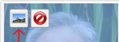
- In the ‘Alternative Text’ box enter your alt text
- Click ‘Update’

Definition of a post

Posts are entries listed in reverse chronological order on the blog home page or on the posts page of your website. Posts can be found in the Archives, Categories, Recent Posts, and other widgets. Posts are also displayed in the RSS feed of the blog. You can control how many posts are displayed at a time in the Reading Settings.

Add a New Page to Navigation Menu

- Login
- Click ‘Pages’
- Click ‘Add New’
- Name the Page and insert content
- The navigation bar is numbered starting from 0 (zero is normally the ‘Home’ page). Decide where you want this page in the navigation and count to see what number coincides with that position.
- Type that number under ‘Order’ on the right side of the editor
- Click ‘Update’ 
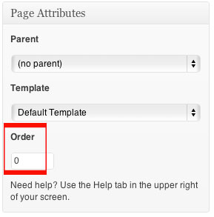

Add a New Page (Not listed In Navigation)

To add a page that will NOT be in your navigation, please follow these steps.

- Login
- Click ‘Pages’
- Click ‘Add New’
- Name the Page and insert content
- Click the button
- Click ‘Appearance’
- Click ‘Chameleon Theme Options’
- Click the button
- Find the page you just created
- Click the green checkmark so it turns into a red X
- Scroll all the way down to the bottom
- Click the  button

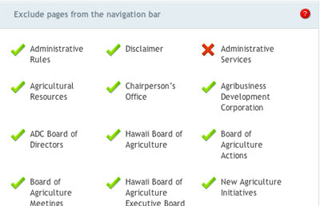

Remove a Page

- Login
- Click ‘Pages’
- Click ‘All Pages’
- Hover over the page you want to remove
- Click ‘Trash’

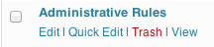

Creating a draft page

- Login
- Click ‘Pages’
- Click ‘Add New’
- Give the page a title
- Add content
- Click button
- The page will stay a draft mode for as long you want
- Once you are ready for the page to be on the site click ‘Publish’

Custom menus

- Login
- Click ‘Appearance’
- Click ‘Menus’
- In ‘Menu Name’ type a name for your custom menu
- Click ‘Create Menu’
- In ‘Theme Locations’ choose the name of the menu you just created
- In ‘Pages’ click ‘View All’ tab
- Click the box next to each pages you want in your custom menu
- Click ‘Add to Menu’
- Now your menu will show up on the top right
- To change the order the items appear in the navigation
  - Hover over the item you want to move
  - Click and Drag to where you want the item to be
  - Repeat until you have all the items in the exact order you want them in the navigation.
- To create drop downs
  - Hover over the item you want to be in the drop down
  - Click and Drag under the item that will be in the main navigation
  - Click and Drag to the right then release (the box will be indented under the main item)
  - Repeat for all drop down items
13. Click ‘Save Menu’

Custom footer
The footer for the State Template can be set up in two different ways. By default, there will be a generic footer set up for your site. If you want to customize your footer, you can do so by following these instructions. Do note that you will have to rebuild all of the footer sections if you choose to have a custom footer.

- Login
- Click ‘Appearance’
- Click ‘Menus’
- Click the tab with the + (plus symbol)
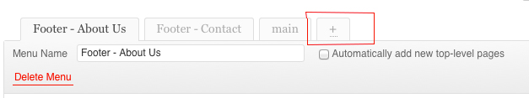

- Type a footer name (use any name you want) in ‘Menu Name’ (ex: Footer-About Us)
**Note: each section of the footer must have its own footer name (contact, about us, policies, links, etc) so you will have to repeat this process for each section.
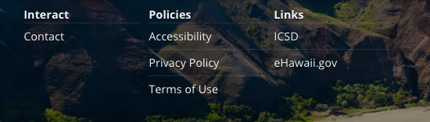

- Click ‘Create Menu’
- To add pages to your footer
  - Under ‘Pages’
  - Click ‘View All’
  - Click the box next to all the pages you want in your footer
  - Click ‘Add to Menu’
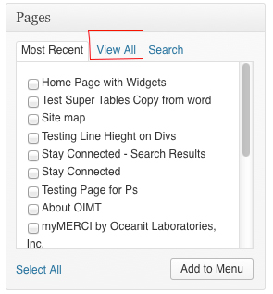

- To add custom links to your footer
  - Under ‘Custom Links’
  - In ‘URL’ type the URL that you want to link to (ex: www.ehawaii.gov)
  - In ‘Label’ type the text you want displayed for the URL (ex: Our Policies)
  - Click ‘Add to Menu’
- To enter in a telephone number
  - Under ‘Custom Links’
  - In ‘Label’ type: <a title=“tel” href=“808-123-4567”> 808-123-4567</a>
**Note: replace the example number with your own number
  - Click ‘Add to Menu’
- To enter an email address
  - Under ‘Custom Links’
  - In ‘URL’ type: mailto: example@yahoo.com
  - In ‘Label’ type: example@yahoo.com
**Note: replace the example email with your own email
  - Click ‘Add to Menu’
- To change the order the items appear in the footer
  - Hover over the item you want to move
  - Click and Drag the box to where you want it
  - Repeat this until all the items are in the order you want them to appear
- Click ‘Save Menu’
- Click ‘Appearance’
- Click ‘Widgets’
- Click the grey arrow in the ‘Footer’ box (location: far right of the page)
- In the ‘Available Widgets’ section
- Find ‘Custom Menu’
- Click and Drag the ‘Custom Menu’ box into the ‘Footer’ section
- Click ‘Save’
- In the ‘Title’ section type the text you want to appear in the actual footer (ex: Contact Us)
- In ‘Select Menu’ choose the footer menu that you want to use (ex: Footer-Contact Us)
- Click ‘Save’
- Repeat steps 16-22 until all the sections of the footer are in the footer widget

